View this email in your browser

Ida’s Vision
Imagine how elated Ida B. Wells and her politically activist sisters, who formed the state’s first black women’s suffrage organization, would be to see two black women in a runoff to become Chicago’s next mayor.

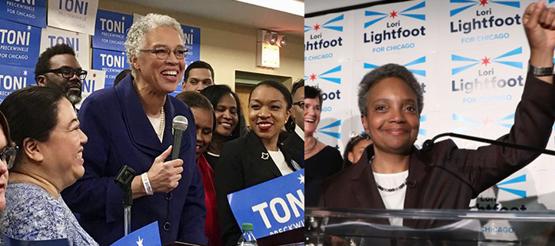

The Alpha Suffrage Club was started in 1913 to get African-American women involved in political activities and support men candidates who they believed would best serve the interests of Chicago’s black communities. The club was in response to a recent Illinois law that granted limited suffrage to women in the state. Under Wells’ leadership the club got thousands of women involved and helped to elect the city’s first black alderman, Republican Oscar de Priest, to represent the 2nd Ward in 1915.
In Wells’ autobiography, she wrote, “We (women) could use our vote for the advantage of ourselves and our race.”
The exclusion of African-American women from white-led suffrage groups was the catalyst for Wells forming the Alpha Suffrage Club. Then, as now, Wells understood that white women’s issues were not always the same as black women’s. So, the club allowed black women to work on social issues that affected them. It also issued newsletters reporting on political and social issues and endorsed candidates.
In 1930, Wells became the first black woman to run for elected office. She ran as an independent candidate for the Illinois state senate. She lost. Her legacy as a political activist, organizer, strategist and pioneer are undeniable, however.
Mayoral candidates Toni Preckwinkle and Lori Lightfoot are standing on Wells’ shoulders. She paved the way for this moment 106 years ago. As black women we can’t squander this opportunity to bring to reality her vision of an equal and just Chicago. In five weeks, one of these two women will be elected to carry on the political legacy of Ida B. Wells.

Delmarie Cobb
Ida’s Legacy Committee

